GuessingGameA Mastery Assignment
Reflection Log
Stefan S
CSE 2110 Procedural Programming 1
(GuessingGame_A.java)
How has your program changed from planning to coding to now? Explain.

The program started as a copy/paste of my original GuessingGame assignment. I deleted the try-except loop to make things easier to read as I worked on it.
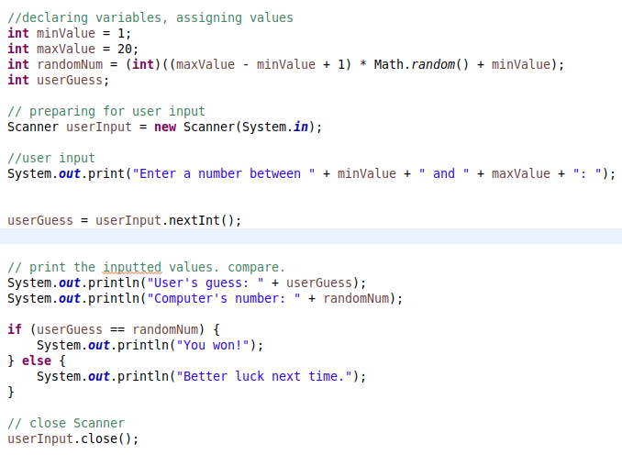

Most of the old code was deleted in the end. The new loop handled most of it.
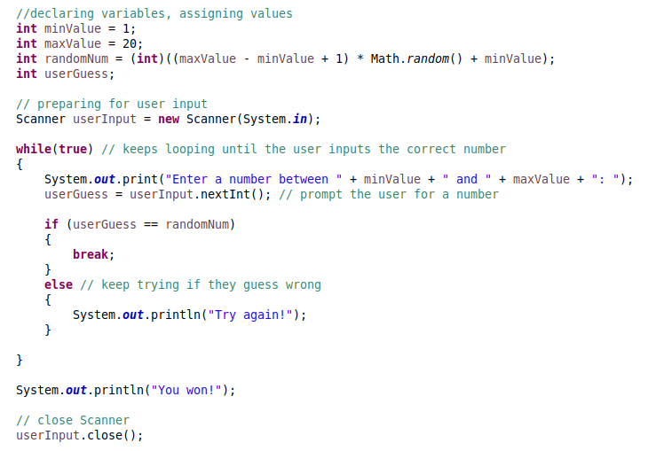
The last thing I did was add a try-except loop to handle errors caused by the user. This was copy pasted back in from the old code.
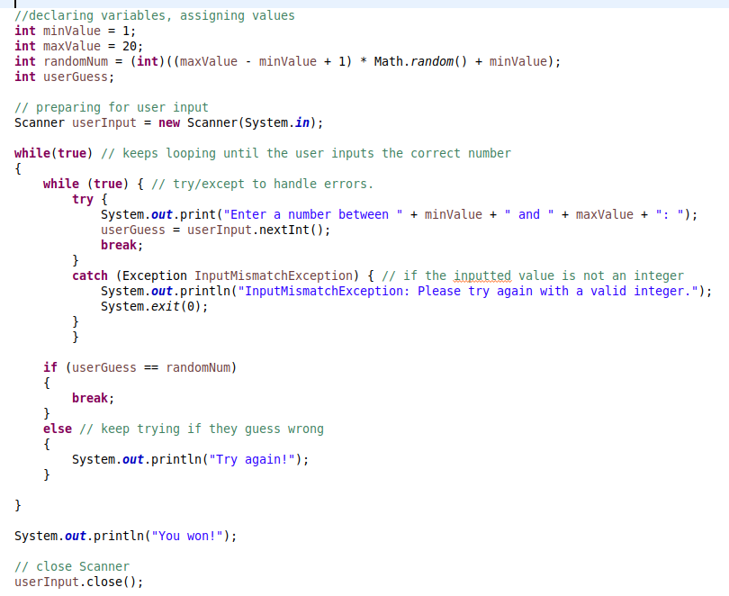
The application was comically quick to make. It also took very little time, given that most of it was already planned out and written. The final application has not changed from what I planned in my IPO

